DAY-7
1.Write a C program to implement infix, prefix and postfix notations for arithmetic expressions using stack
#include <stdio.h>
#include <stdlib.h>
#include <string.h>
#define MAX_SIZE 100
struct Stack {
int top;
char items[MAX_SIZE];
};
void initialize(struct Stack* stack) {
stack->top = -1;
}
int isFull(struct Stack* stack) {
return stack->top == MAX_SIZE - 1;
}
int isEmpty(struct Stack* stack) {
return stack->top == -1;
}
void push(struct Stack* stack, char item) {
if (isFull(stack)) {
printf("Stack Overflow\n");
exit(EXIT_FAILURE);
}
stack->items[++stack->top] = item;
}
char pop(struct Stack* stack) {
if (isEmpty(stack)) {
printf("Stack Underflow\n");
exit(EXIT_FAILURE);
}
return stack->items[stack->top--];
}
char peek(struct Stack* stack) {
if (isEmpty(stack)) {
printf("Stack is empty\n");
exit(EXIT_FAILURE);
}
return stack->items[stack->top];
}
int isOperator(char ch) {
return (ch == '+' || ch == '-' || ch == '*' || ch == '/');
}
int getPrecedence(char ch) {
switch (ch) {
case '+':
case '-':
return 1;
case '*':
case '/':
return 2;
}
return -1;
}
void infixToPostfix(char infix[], char postfix[]) {
struct Stack stack;
initialize(&stack);
int i, j;
char ch, topOperator;
j = 0;
for (i = 0; infix[i] != '\0'; i++) {
ch = infix[i];
if (isOperator(ch)) {
while (!isEmpty(&stack) && getPrecedence(ch) <= getPrecedence(peek(&stack))) {
postfix[j++] = pop(&stack);
}
push(&stack, ch);
} else if (ch == '(') {
push(&stack, ch);
} else if (ch == ')') {
while (!isEmpty(&stack) && peek(&stack) != '(') {
postfix[j++] = pop(&stack);
}
if (isEmpty(&stack) || peek(&stack) != '(') {
printf("Invalid infix expression\n");
exit(EXIT_FAILURE);
}
pop(&stack);
} else {
postfix[j++] = ch;
}
}
while (!isEmpty(&stack)) {
if (peek(&stack) == '(') {
printf("Invalid infix expression\n");
exit(EXIT_FAILURE);
}
postfix[j++] = pop(&stack);
}
postfix[j] = '\0';
}
void reverseString(char string[]) {
int length = strlen(string);
int i;
char temp;
for (i = 0; i < length / 2; i++) {
temp = string[i];
string[i] = string[length - i - 1];
string[length - i - 1] = temp;
}
}
void infixToPrefix(char infix[], char prefix[]) {
reverseString(infix);
int i;
for (i = 0; infix[i] != '\0'; i++) {
if (infix[i] == '(') {
infix[i] = ')';
} else if (infix[i] == ')') {
infix[i] = '(';
}
}
infixToPostfix(infix, prefix);
reverseString(prefix);
}
int main() {
char infix[MAX_SIZE], postfix[MAX_SIZE], prefix[MAX_SIZE];
printf("Enter an infix expression: ");
fgets(infix, sizeof(infix), stdin);
infix[strlen(infix) - 1] = '\0';
infixToPostfix(infix, postfix);
printf("Postfix expression: %s\n", postfix);
infixToPrefix(infix, prefix);
printf("Prefix expression: %s\n", prefix);
return 0;
}
OUTPUT:
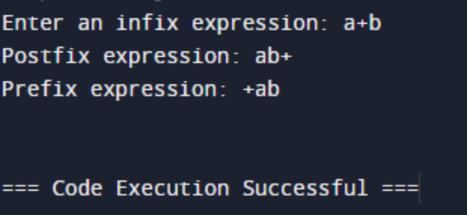

2.Write a C program to check if the parentheses in an expression are balanced using a stack. Extend the program to handle multiple types of parentheses (e.g., {}, [], ()).
#include <stdio.h>
#include <stdlib.h>
#include <string.h>
#define MAX_SIZE 100
struct Stack {
int top;
char items[MAX_SIZE];
};
void initialize(struct Stack *s) {
s->top = -1;
}
void push(struct Stack *s, char c) {
s->items[++s->top] = c;
}
char pop(struct Stack *s) {
return s->items[s->top--];
}
int areParenthesesBalanced(char exp[]) {
struct Stack s;
initialize(&s);
for (int i = 0; i < strlen(exp); i++) {
if (exp[i] == '(' || exp[i] == '{' || exp[i] == '[') {
push(&s, exp[i]);
} else if (exp[i] == ')' || exp[i] == '}' || exp[i] == ']') {
if (s.top == -1) {
return 0;
} else if ((exp[i] == ')' && s.items[s.top] == '(') ||
(exp[i] == '}' && s.items[s.top] == '{') ||
(exp[i] == ']' && s.items[s.top] == '[')) {
pop(&s);
} else {
return 0;
}
}
}
return s.top == -1 ? 1 : 0;
}
int main() {
char exp[MAX_SIZE];
printf("Enter an expression: ");
scanf("%s", exp);
if (areParenthesesBalanced(exp)) {
printf("Parentheses are balanced.\n");
} else {
printf("Parentheses are not balanced.\n");
}
return 0;
}
OUTPUT:
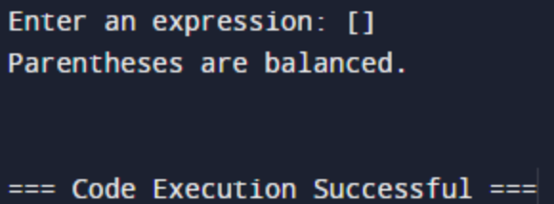
3.Write a program to evaluate a postfix expression using a stack. The program should handle basic arithmetic operators (+, -, *, /).
#include <stdio.h>
#include <stdlib.h>
#include <ctype.h>
#define MAX_SIZE 100
int stack[MAX_SIZE];
int top = -1;
void push(int item) {
if (top >= MAX_SIZE - 1) {
printf("Stack Overflow\n");
exit(1);
}
stack[++top] = item;
}
int pop() {
if (top < 0) {
printf("Stack Underflow\n");
exit(1);
}
return stack[top--];
}
int evaluatePostfix(char* exp) {
int i = 0;
while (exp[i] != '\0') {
if (isdigit(exp[i])) {
push(exp[i] - '0');
} else {
int val1 = pop();
int val2 = pop();
switch (exp[i]) {
case '+':
push(val2 + val1);
break;
case '-':
push(val2 - val1);
break;
case '*':
push(val2 * val1);
break;
case '/':
push(val2 / val1);
break;
}
}
i++;
}
return pop();
}
int main() {
char exp[] = "82/3-32*+";
printf("Result of the postfix expression %s is %d\n", exp, evaluatePostfix(exp));
return 0;
}
OUTPUT:
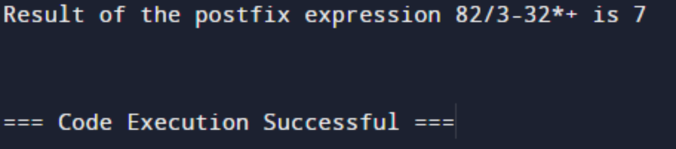

4.Write a C program to solve the Tower of Hanoi problem using recursion.
#include <stdio.h>
void towerOfHanoi(int n, char source, char destination, char auxiliary) {
if (n == 1) {
printf("Move disk 1 from %c to %c\n", source, destination);
return;
}
towerOfHanoi(n - 1, source, auxiliary, destination);
printf("Move disk %d from %c to %c\n", n, source, destination);
towerOfHanoi(n - 1, auxiliary, destination, source);
}
int main() {
int numDisks;
printf("Enter the number of disks: ");
scanf("%d", &numDisks);
printf("Tower of Hanoi solution:\n");
towerOfHanoi(numDisks, 'A', 'C', 'B');
return 0;
}
OUTPUT:
